|  |  |
| --- | --- |
|  | |
|  | |
|  |  |

|  |  |
| --- | --- |
| Publication type: |  |
| Publication number: | ACC |
| Title: |  |
| Subject: |  |
| Issue: | 2.1.1 |
| Publication date: | 17 December 2014 |
| Total number of pages: |  |
| Author: |  |
| Quality Control: |  |

Table of contents

Page #

References 5

Introduction 6

About the Operating Manual 6

Safety instructions 7

Revision history 7

1. Introduction 8

2. Installation and settings 8

2.1 Downloading 8

2.2 Settings 8

3. The program 10

3.1 Alarm mimic 11

3.1.1 Colors and icons 13

3.1.2 Alarm values and setpoints 15

3.2 Instrument Mimic 16

Figures

Figure 2‑1: Seagull HD Icon 8

Figure 2‑2: Seagull HD Settings 9

Figure 2‑3: Color Palette modes 9

Figure 3‑1: Alarm mimic (default) 10

Figure 3‑2: Instrument mimic 11

Figure 3‑3: Selecting alarm station 12

Figure 3‑4: Warning and inhibited 13

Figure 3‑5: Alarm icons 14

Figure 3‑6: Setpoints and actual value 15

Figure 3‑7: Alarms extra information 15

Figure 3‑8: First start up instrument mimic 16

Figure 3‑9: Instrument choices 17

Figure 3‑10: Field Overlay 17

Figure 3‑11: 1 instrument configured 18

Figure 3‑12: Fully filled instrument mimic 19

# 

**NOTICE**

**This document contains proprietary information.**

**No part of this document may be photocopied, reproduced or translated into another language without the prior written consent of   
Imtech B.V.**

References

[1] ACC-NavVision-Operators-Manual v2.1.2

Introduction

This manual contains all essential information for the user to make full use of NavVision Tablet version. This manual includes a description of the alarm functions, monitoring functions and additional capabilities. Also described are contingencies and alternate modes of operation, as well as step-by-step procedures for system access and use. For now the tablet version will be restricted to the iPad. An Android version will follow shortly.

About the Operating Manual

This manual contains the following sections:

* *Safety instructions* presents warning, caution and note information, which the user should pay attention to;
* *Installation and Settings* handles about all the necessary steps to install and setup the mobile NavVision version;
* *Program* handles about all the settings within the program itself;

For specific information on interfaces, but also in depth information on features, mentioned here or not, we refer you to their specific manuals which can be obtained through Imtech.

# Safety instructions

* This section provides only a summary of the safety requirements and notes in the following sections. To protect your health and prevent damage to the AM(C)S equipment or vessel, it is essential to read and carefully follow the safety instructions.*

The indications NOTE, CAUTION and WARNING have the following significance:



*NOTE:  
An operating procedure, practice or condition etc., which it is important to emphasize.*

**

*CAUTION:*

*An operating procedure, practise or condition etc., which, if not strictly observed, may damage AM(C)S equipment or crash NavVision software.*

* WARNING:*

*An operating procedure, practise or condition etc., which, if not carefully observed may result in personal injury or damage to the vessel.*

Revision history

Revisions issued since publication.

|  |  |  |  |
| --- | --- | --- | --- |
| **Issue** | **Date** | **Revision** | **Reason** |
| 2.1.1 | December 16, 2014 | New version | Initial release |

# Introduction

With the ongoing movement towards applications for and usage of tablets, we decided to implement the NavVision HMI into these platforms. The goal is that these tablets can be used as a fully operational duty-station. We will implement this in scalable portions. For now we started with the implementation of the alarm mimic together with a small, adjustable mimic that can show 6 fields which can be used as a conning mimic for example.

# Installation and settings

## Downloading

First of all you need to download the program from the App Store. For information of how to download, we refer you to the information you got with your device.

Search for the App: Seagull HD. It will appear as one of the first items in your search. The program can be recognized by the icon as shown in Figure 2‑1. Make sure that the developer is “Free Technics BV.”



Figure 2‑1: Seagull HD Icon

## Settings

After downloading and installing the App, you need to fill in some details in the settings screen. You will find this settings under your settings icon on your device. Scroll down until you find the Seagull HD icon. When you click on that icon you see the settings as shown in Figure 2‑2.

On the right side you’ll notice the settings. There is a toggle-switch to put the system in Demo-mode. This is to show you all the possibilities of the system when not connected. Below that you will find the Color Palette. By clicking at the arrow at the end you can choose to switch between day-, dusk- or night-mode (see Figure 2‑3).

On the network part you can fill in the main server to connect to (Server 1 IP) and the backup server (Server 2 IP). At the main server you fill in the IP address of the server that NavVision will connect to. If you have a backup system, you can put that IP address in the Server 2 IP field. If NavVision is unable to connect to the first (main) server, it will automatically try to connect to the backup.

Once you finished these settings, NavVision is ready to run.

**

Make sure that you filled in the right IP address, that the WIFI on your device is switched to on and that you are in range of the network.

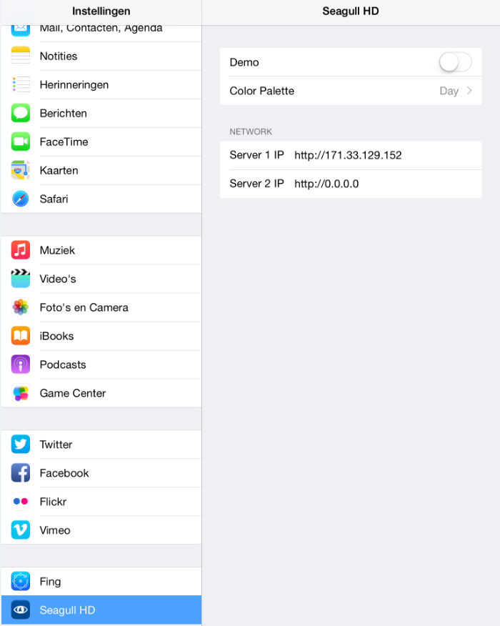

Figure 2‑2: Seagull HD Settings

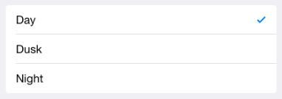

Figure 2‑3: Color Palette modes

# The program

Open the program by clicking on the “Seagull HD” icon on your device. The program will open and show the (default) alarm mimic (see Figure 3‑1).

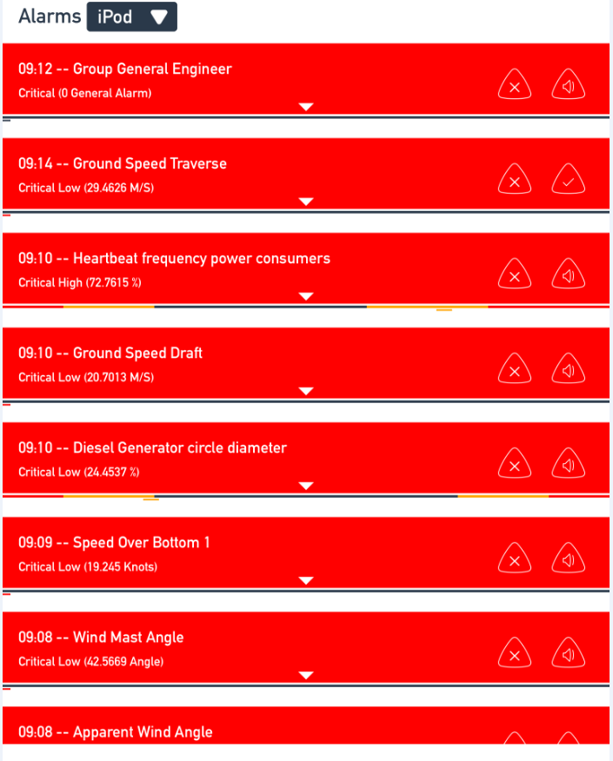

Figure 3‑1: Alarm mimic (default)

When you scroll the page to the left, you will see the freely adjustable mimic appear (see Figure 3‑2).



If there are no alarms to be shown, the alarm mimic can seem to be empty. This is not the case but do check if your connection is alright to make sure.

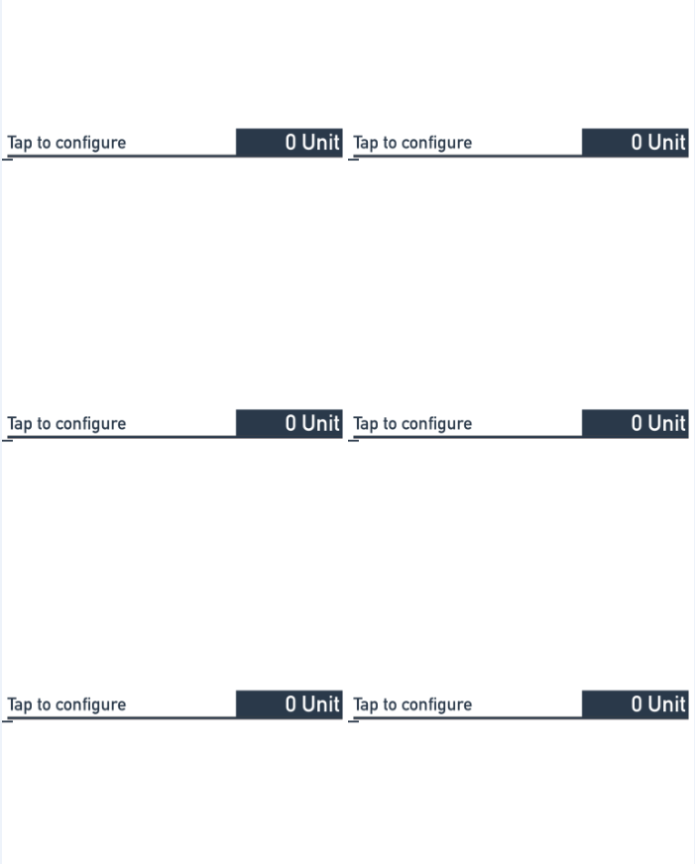

Figure 3‑2: Instrument mimic

## Alarm mimic

By default the alarm mimic will be set to iPod as the main alarm station. By clicking on the field “iPod” you can choose between all the different alarm stations (see Figure 3‑3). You select here which station your device will be representing. Herewith you also decide which rights your station will have and which alarms it will show, while this will be set in the alarm matrix in the actual program.

**

To set the rights for the specific alarm station you choose, you need to use the AlarmMatrix in NavVision itself. For more information we refer you to the operators’ manual.

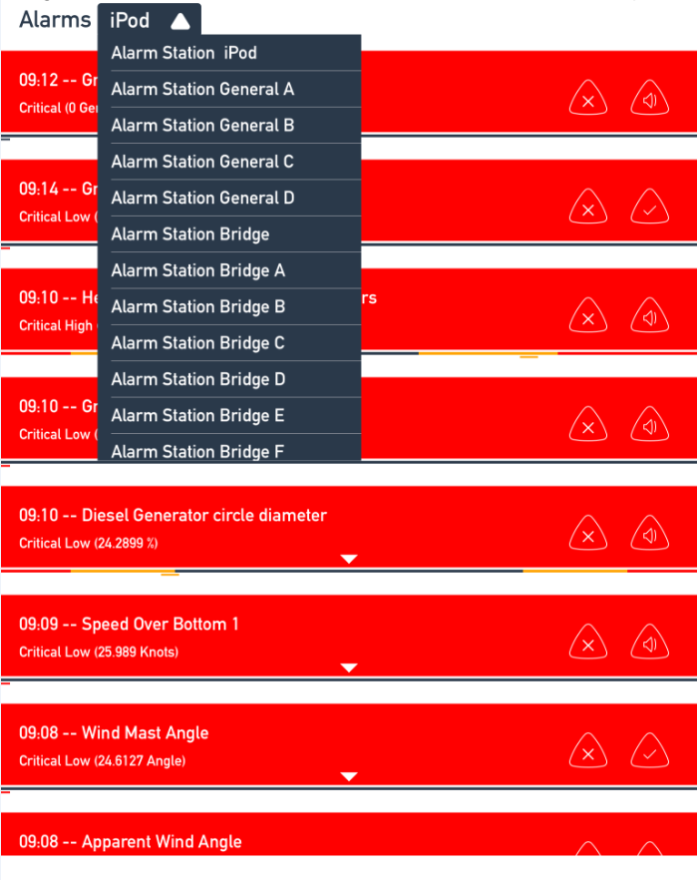

Figure 3‑3: Selecting alarm station

In this case we choose the tablet to act as “Alarm Station iPod” and we have set that it shows all alarms directly and that these alarms can be silenced for 3 minutes. When alarms come in, they will be sorted to priority. On top are always the critical alarms with the newest alarm first. After that the warning alarms will be shown, also the newest alarm first. Last will be the inhibited fields (see Figure 3‑4).

**

If you choose your device to act as an Engine Room, you probably won’t get all the rights that an Engine Room has. While the ER is the most likely place to get to acknowledge the alarms, these rights will not inherit to the tablet. For acknowledgement you need to be on the spot where you can act directly on the alarms. With the tablet it is possible that you are not there at the moment of the alarm. Therefore, even as an engine Room Alarm Station, you can only silence the alarms.

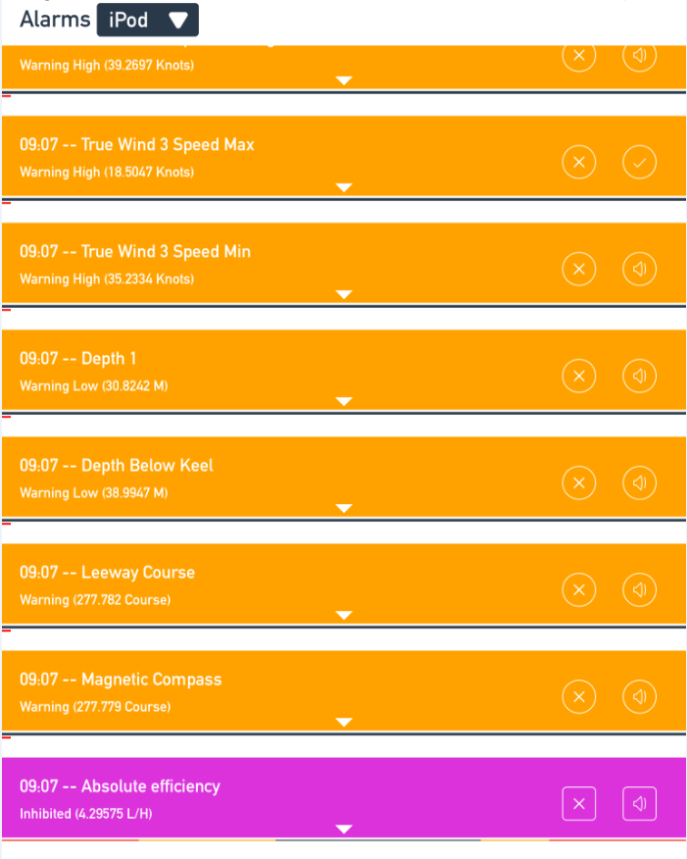

Figure 3‑4: Warning and inhibited

### Colors and icons

The color coding will be as follows:

* Critical alarms Red Triangular
* Warning alarms Orange Oval
* Inhibited Purple Square

Depending on the rights, the following icons may appear. The shape depends on the color they are shown on.

|  |  |
| --- | --- |
|  | Critical alarm: Unacknowledged |
|  | Critical alarm: Silenced |
|  | Critical alarm: Acknowledge not allowed |
|  | Critical alarm: Acknowledged |
|  | Critical alarm: Rectified |
|  | Critical alarm: Transferred |
|  | Warning: Unacknowledged |
|  | Warning: Silenced |
|  | Warning: Acknowledge not allowed |
|  | Warning: Acknowledged |
|  | Warning: Rectified |
|  | Warning: Transferred |
|  | Inhibited: Unacknowledged |
|  | Inhibited: Silenced |
|  | Inhibited: Acknowledge not allowed |
|  | Inhibited: Acknowledged |
|  | Inhibited: Rectified |
|  | Inhibited: Transferred |

Figure 3‑5: Alarm icons

### Alarm values and setpoints

Under each alarm you can see the actual value of that particular field. There is a small rectangle sliding underneath the alarm message that represents the actual value (see Figure 3‑6).

In that same part you can see the setpoints for that field. Left are the low alarms and right are the high alarms. The colors are according to BAM; red is critical, orange is warning and yellow is caution.

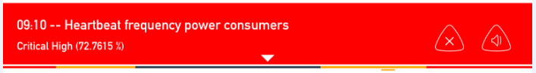

Figure 3‑6: Setpoints and actual value

If you open the alarm by clicking on the triangle at the bottom, the alarmfield opens up to show more information (see Figure 3‑7). Amongst the alarm-time, the alarm-name and the icons mentioned before, you will get extra information.

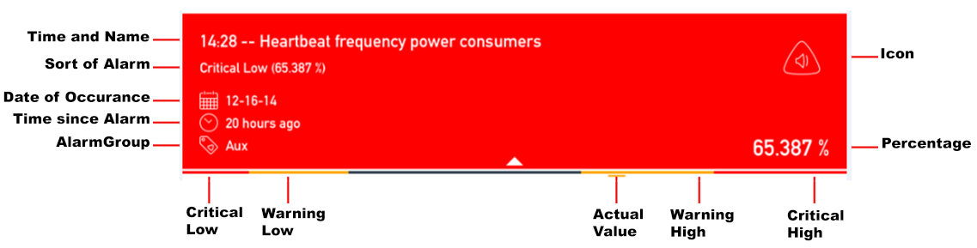

Figure 3‑7: Alarms extra information

## Instrument Mimic

The instrument mimic is a mimic with 6 placeholders for an instrument. Each instrument is completely freely adjustable. You can choose to show whatever information on the instrument, as long as it is available on the main NavVision server.

The windows opens the first time with a standard mimic screen that is filled with 6 non configured instruments (see Figure 3‑8). By clicking on one of these instruments a new window will appear with a few choices (see Figure 3‑9).

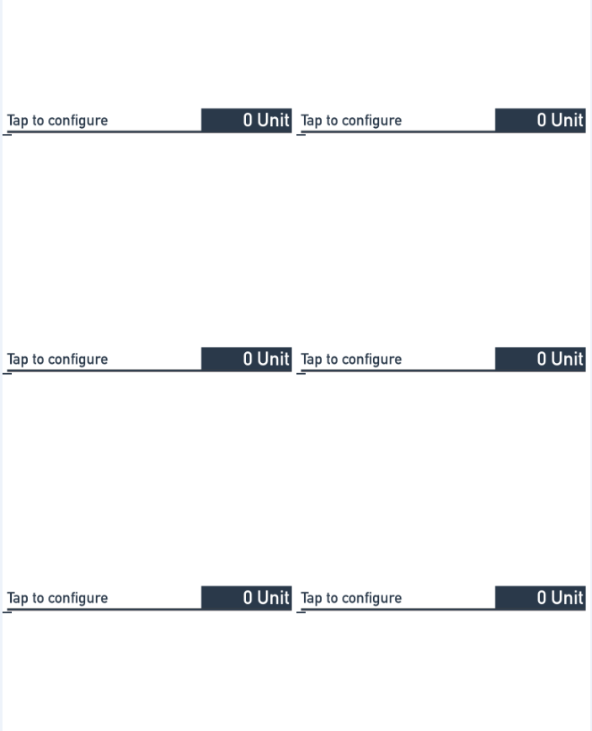

Figure 3‑8: First start up instrument mimic

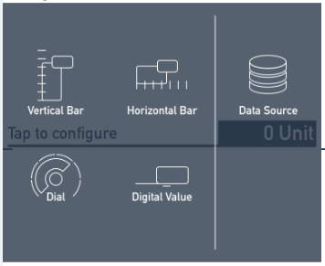

Figure 3‑9: Instrument choices

You can choose for 4 different instrument layouts:

* Vertical Bar Tanks etc.
* Horizontal Bar Rudder, Thruster etc.
* Dial RPM, Wind etc.
* Digital Value All else

Depending on the field that you want to represent here you choose your layout. But first you choose the Data Source for that instrument, by clicking on “Data Source”. This opens an overlay where you can choose the right field for the instrument (see Figure 3‑10).

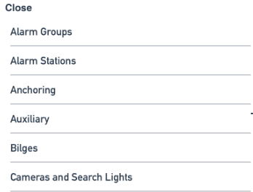

Figure 3‑10: Field Overlay

For example we choose “True Wind Angle” and we choose the Dial as an instrument layout. After this we have the True Wind Angle information live on our mimic (see Figure 3‑11).

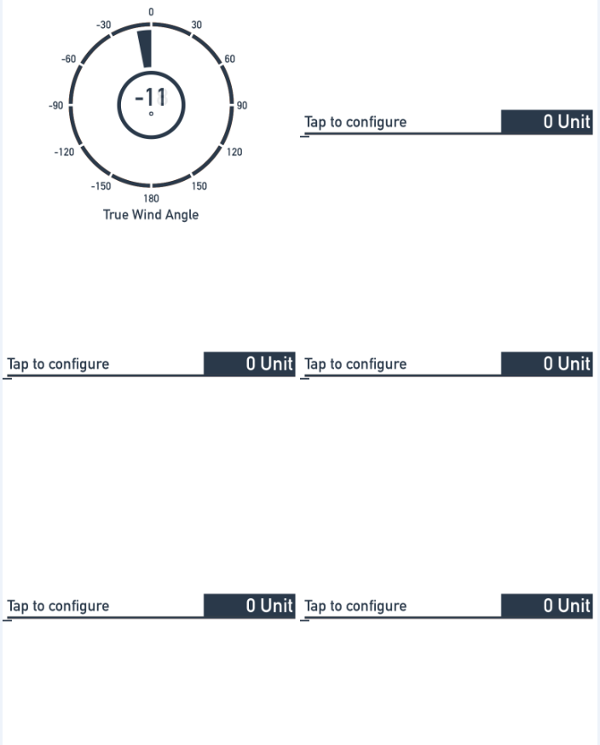

Figure 3‑11: 1 instrument configured

This way you can fill al the 6 instruments to your liking. Eventually it can look like the example below (see Figure 3‑12).

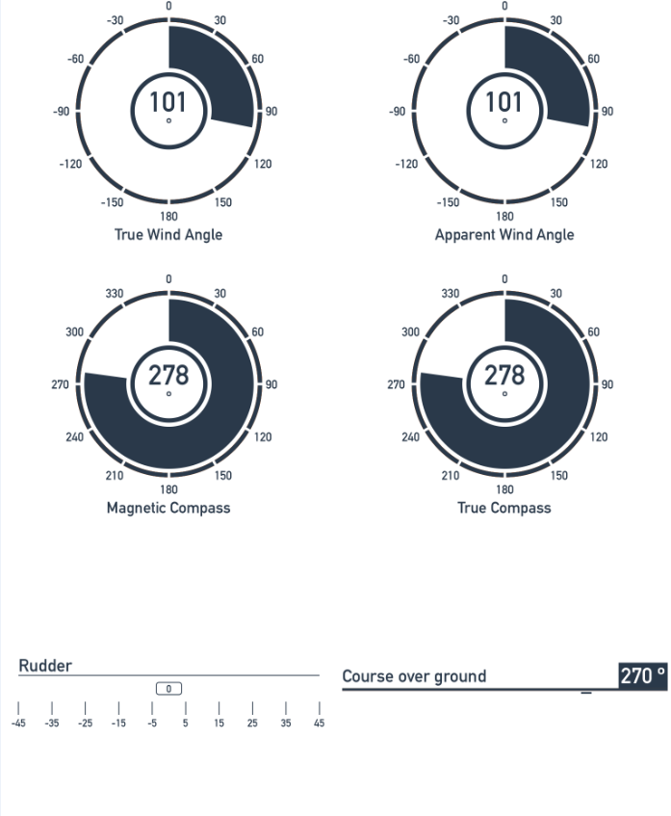

Figure 3‑12: Fully filled instrument mimic